Download and Install MySQL
- Go to http://dev.mysql.com/downloads/.
- You need to download MySQL Community Server (GPL). Click on the appropriate link.
- You should be here now - http://dev.mysql.com/downloads/mysql/.
- Scroll down, and select your platform.
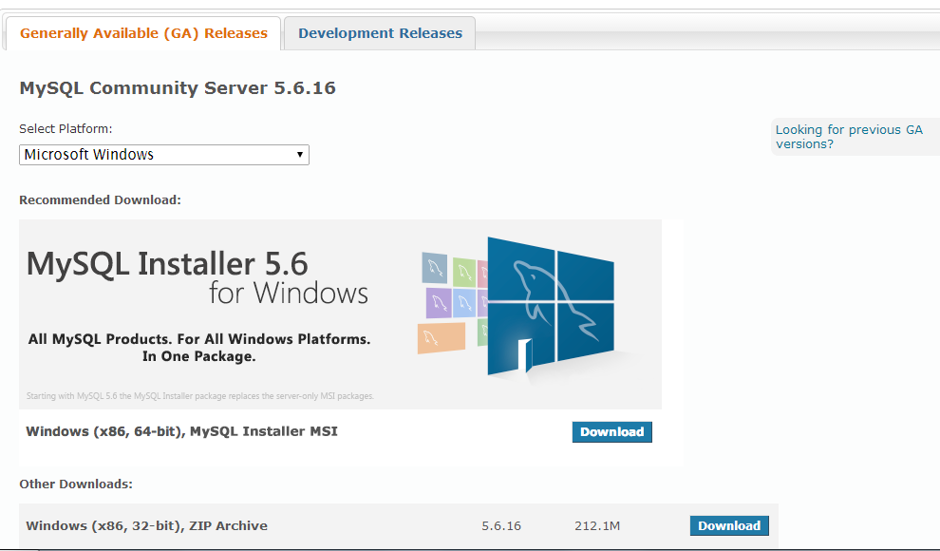
NOTE: If you have a Windows machine, please make sure that you check how many bits your computer is.
- The following steps are for the Windows (x86, 64-bit), MySQL Installer MSI option.
- When you click on download, it will take you to the following screen. (You will have to scroll down)
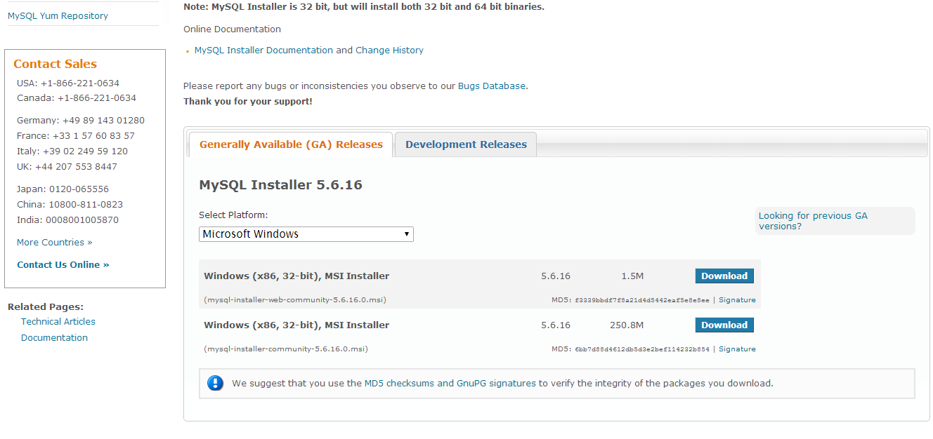
- I am going with the smaller (Web) version of the installer.
- Next, Sign up for an Oracle Web Account.
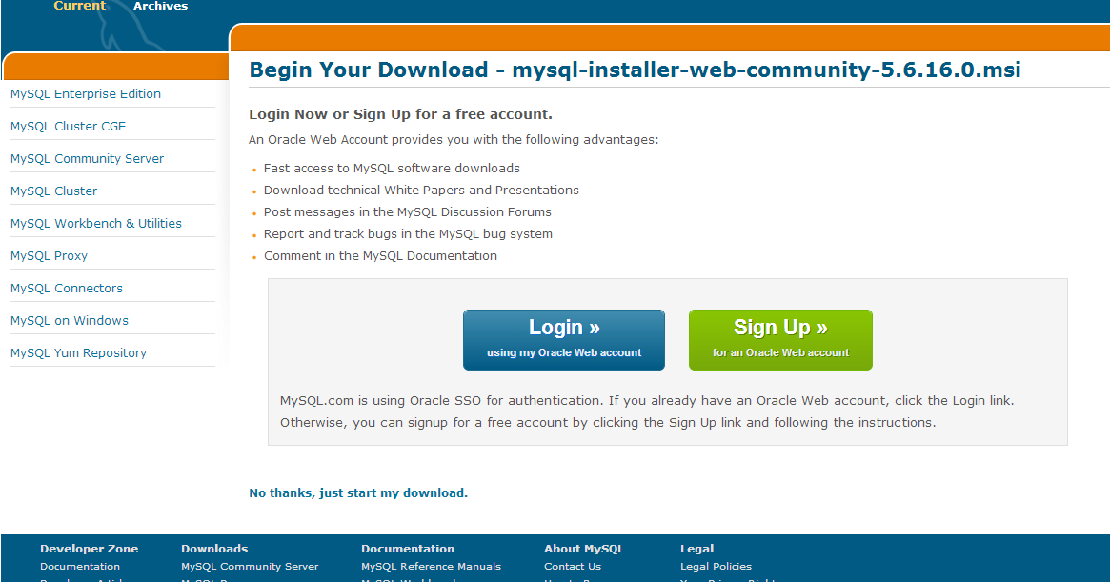
- 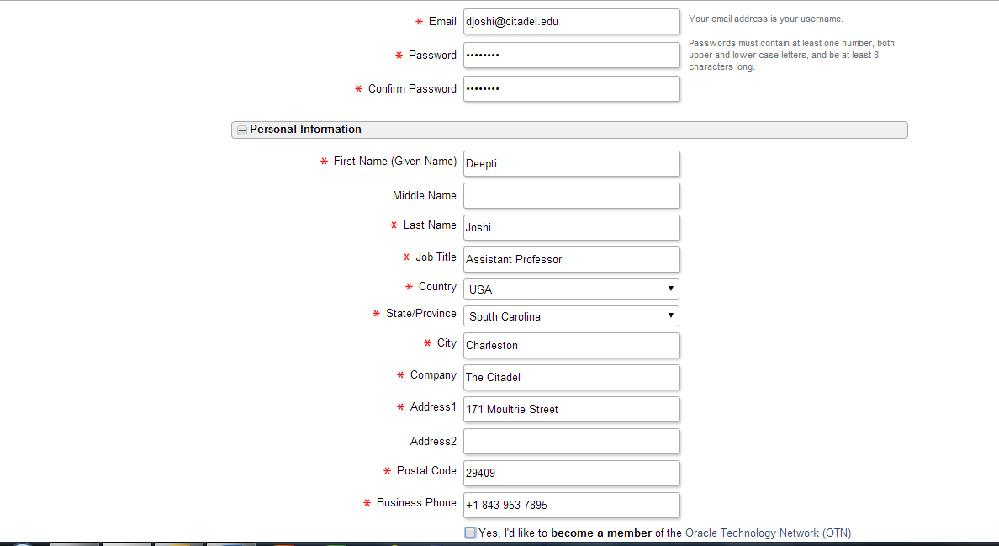
- Next, you will be asked to answer some simple questions before you can begin your download.
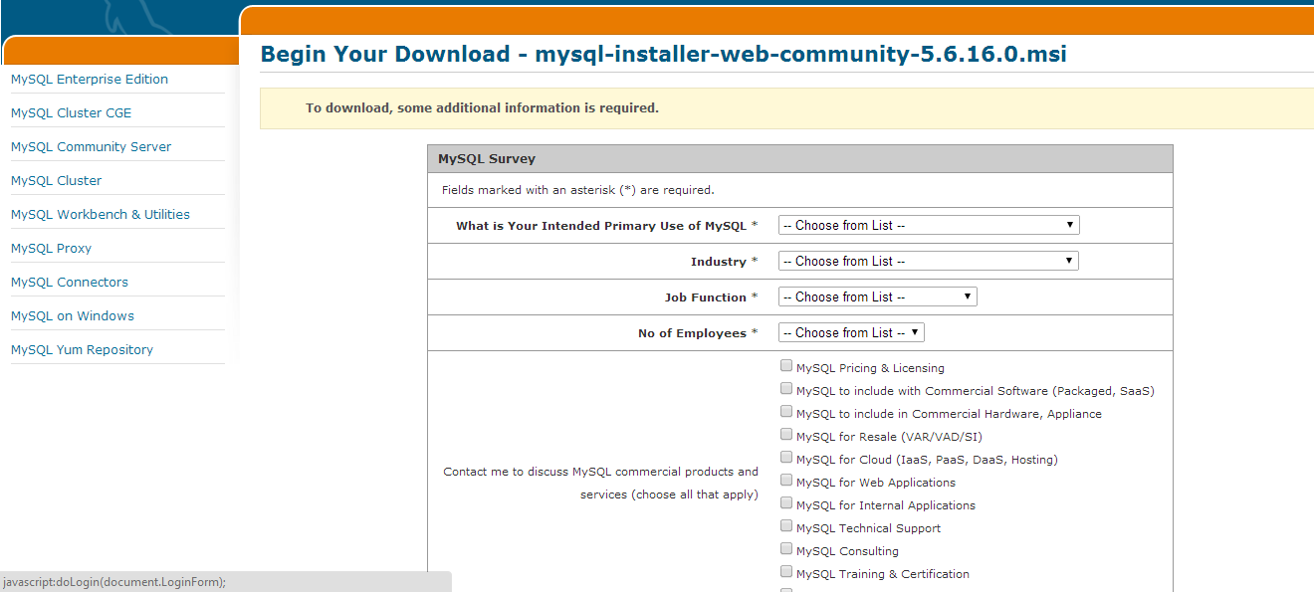
- Answer as follows:
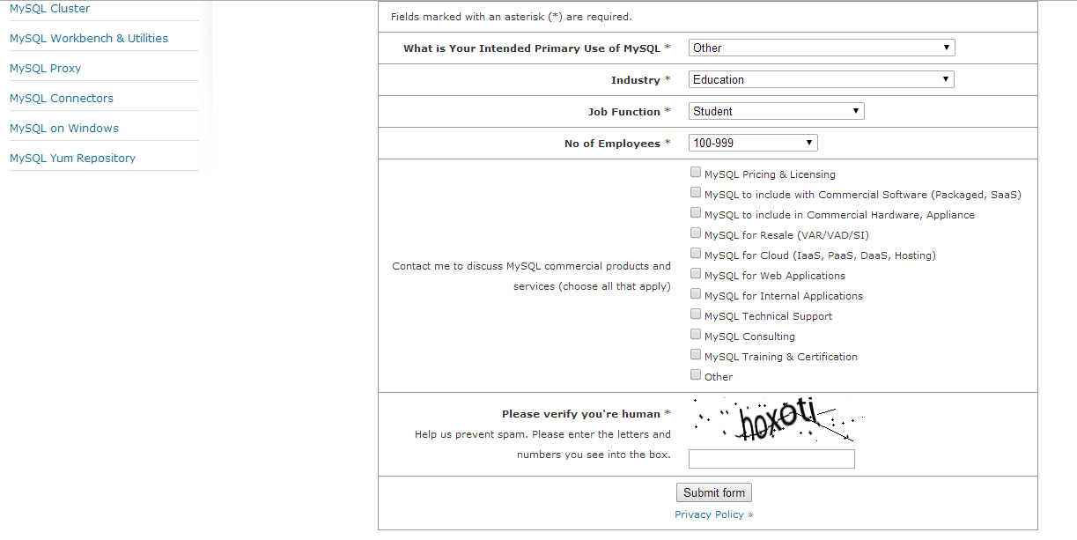
- 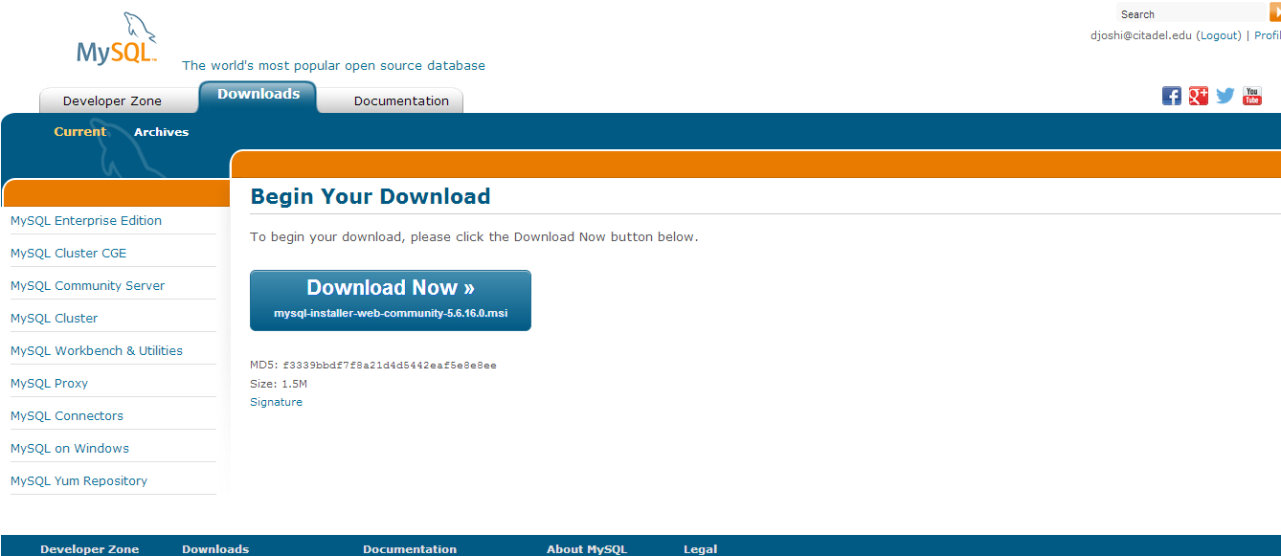
- 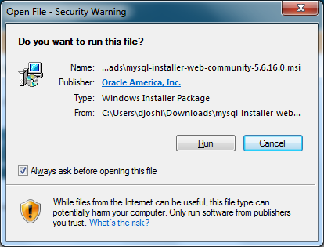
- Click on Run.
- When it asks permission to make changes to your computer, please click on Yes.
- 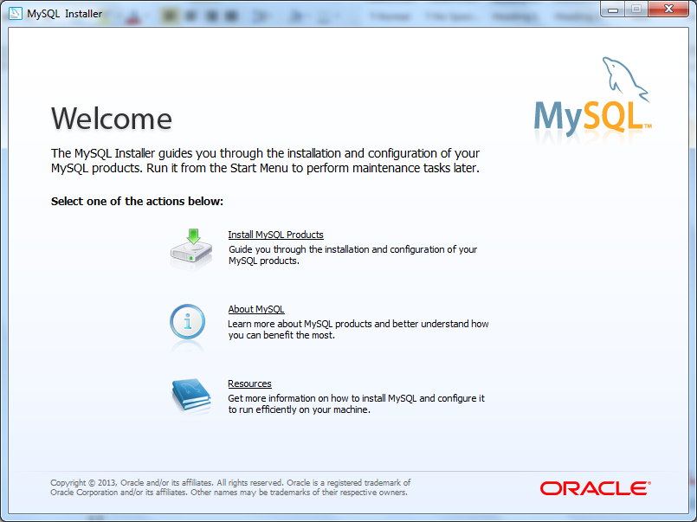
- Click on Install MySQL Products.
- 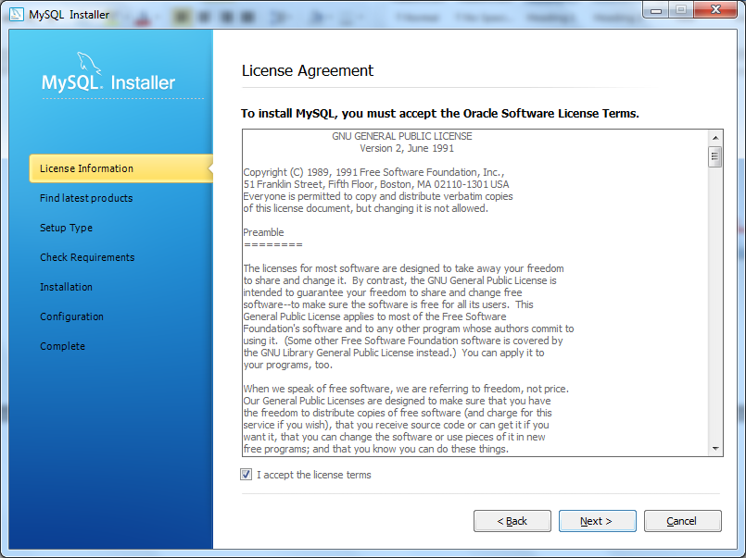
- Click Next
- 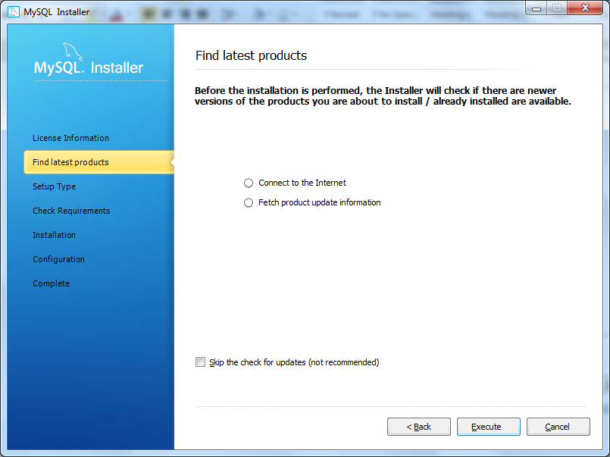
- Click Execute.
- 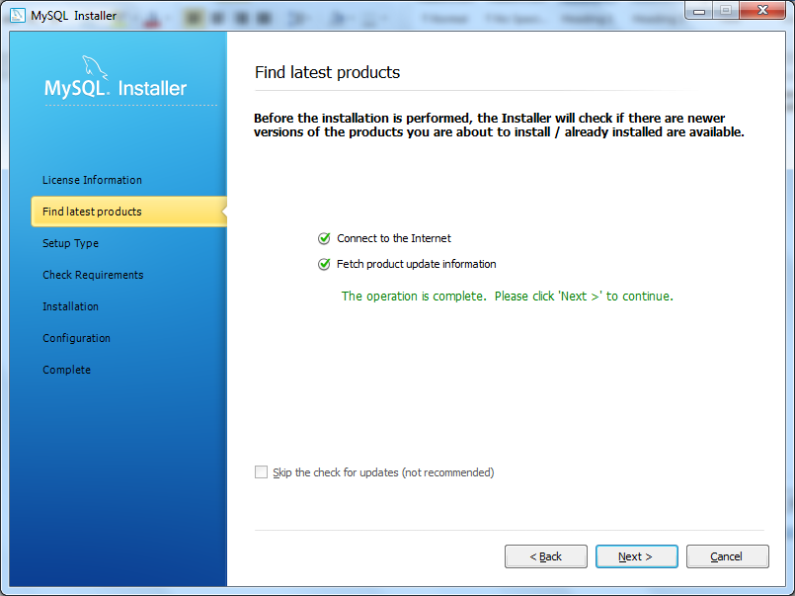
- On the next screen, click on Full.
- 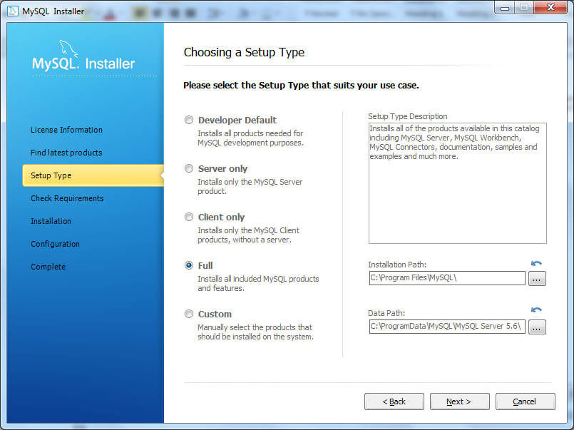
- Click Next.
- 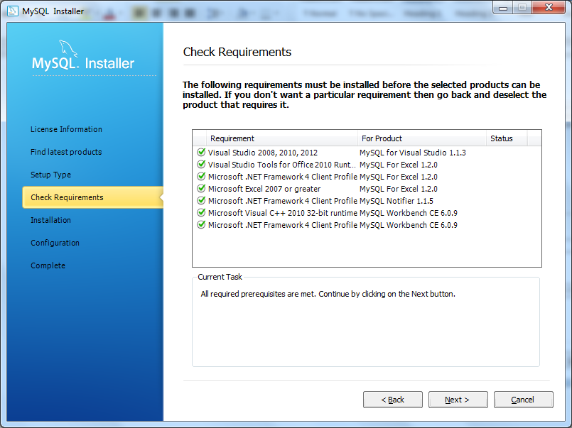
- Click on Next.
- The following screen will appear
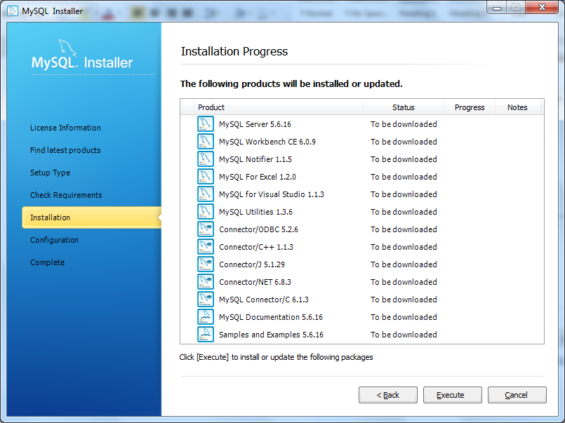
- Click on Execute.
- 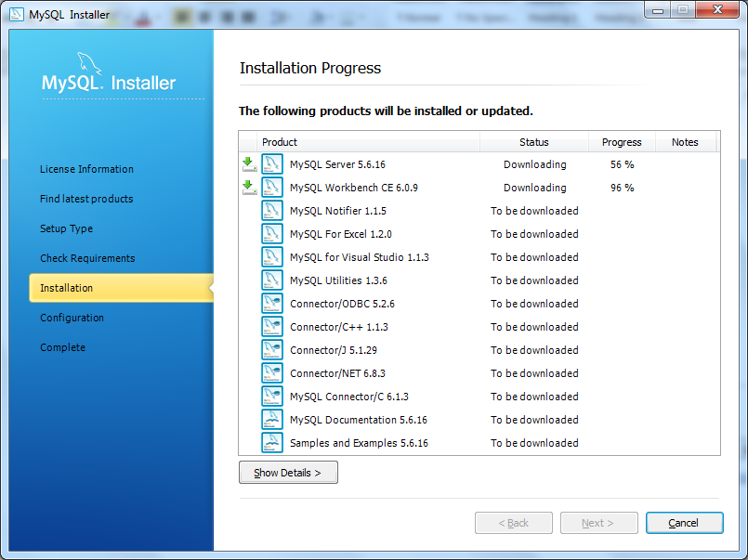
- 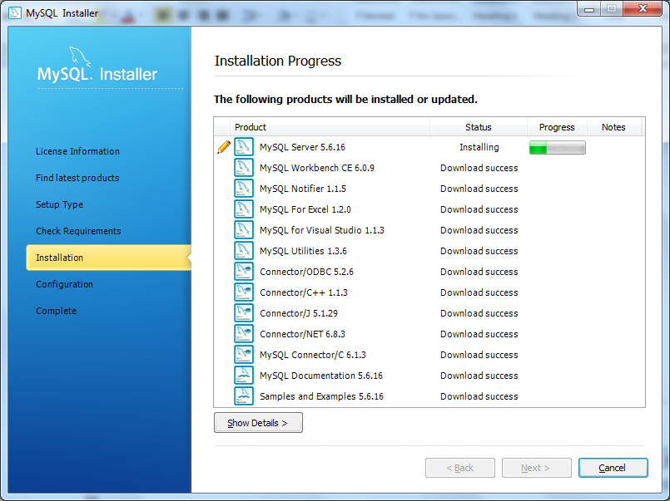
- 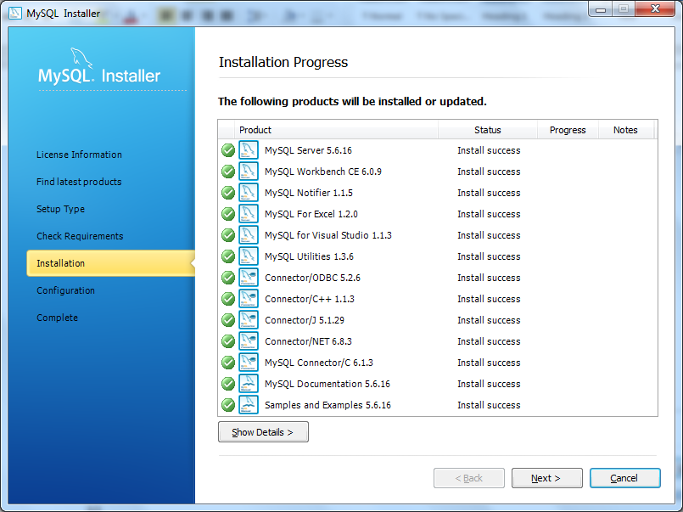
- 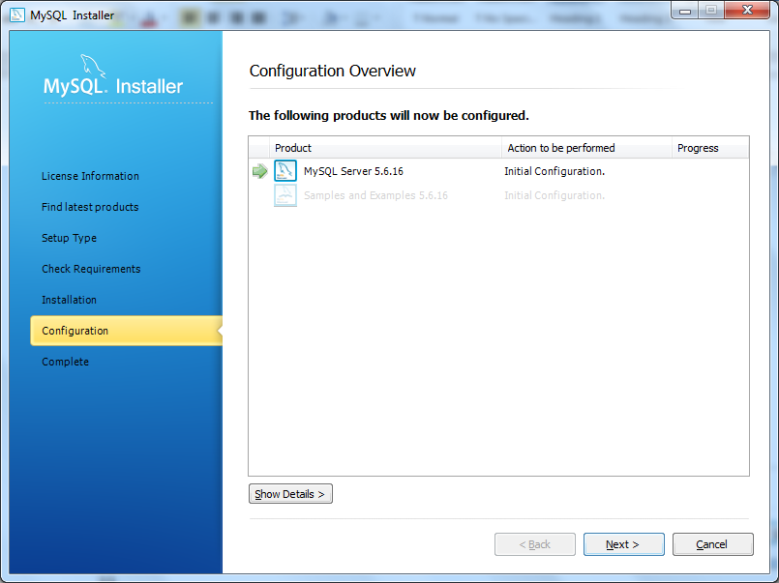
- 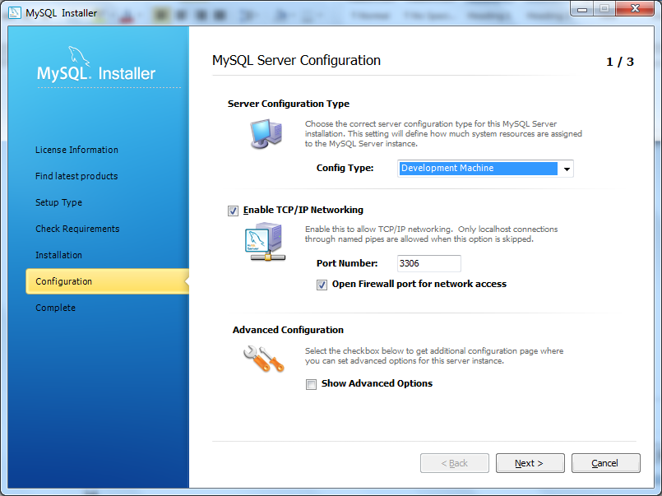
- Click Next. The following screen will appear.
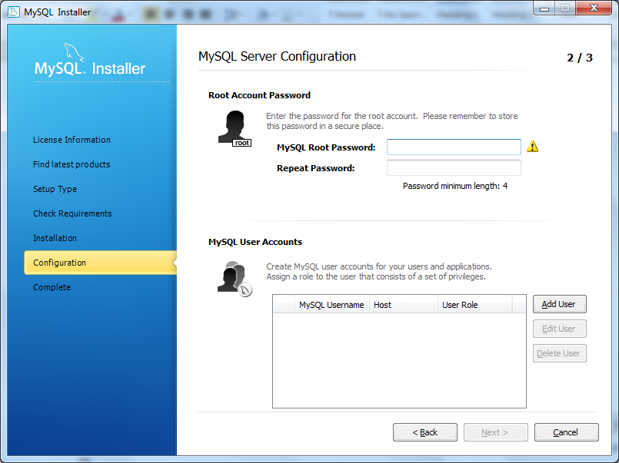
Please note that this is a very important step.
- Select a password that is easy to remember for you.
- You may use a password such as Password for this installation, as this is only for educational purposes.
- Next, click on Add User.
- 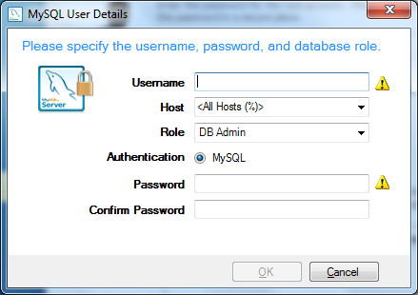
- Create a user name for yourself. For example:
- 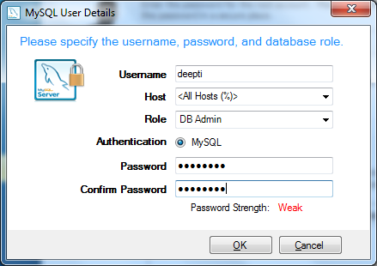
- Keep the DB Admin role for yourself so that you have the rights to go in and make changes as desired.
- 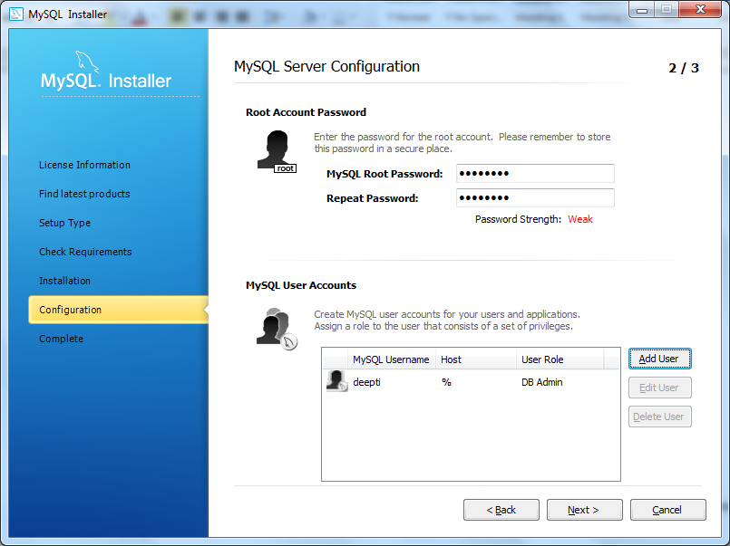
- 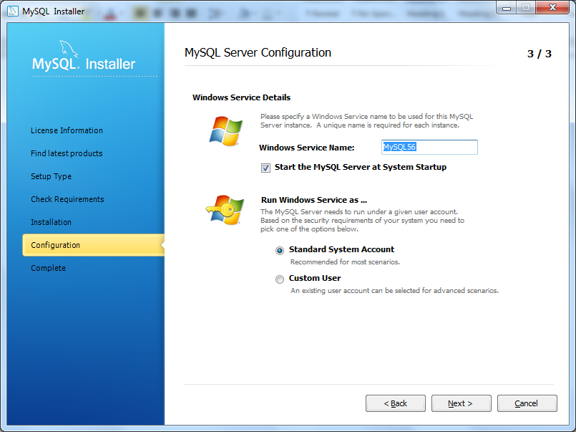
- 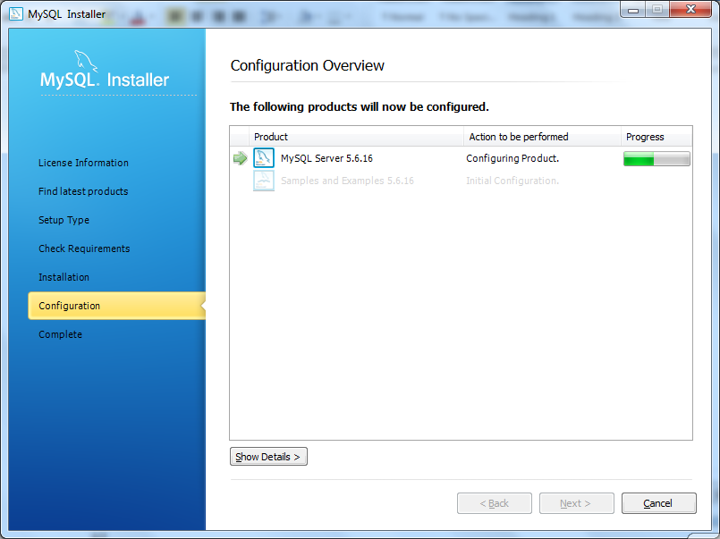
- 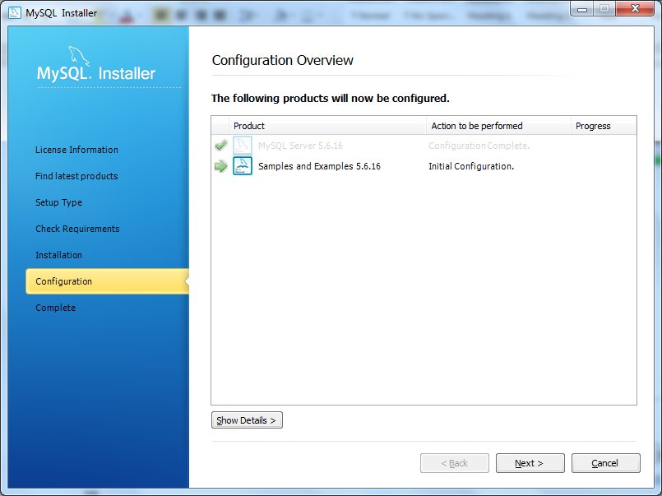
- 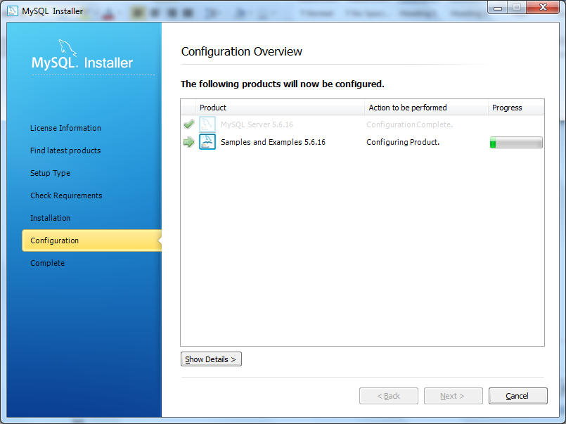
- 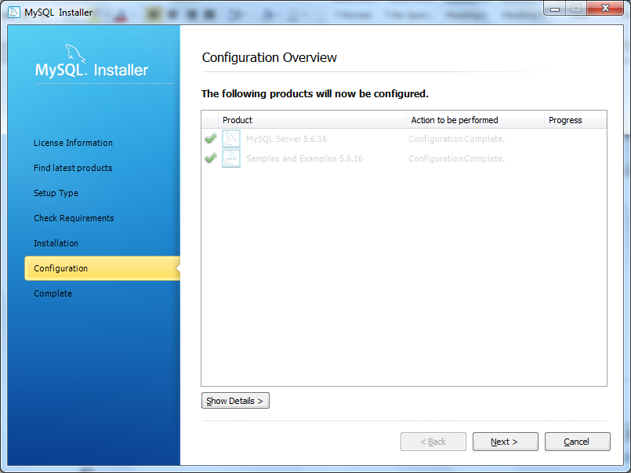
- 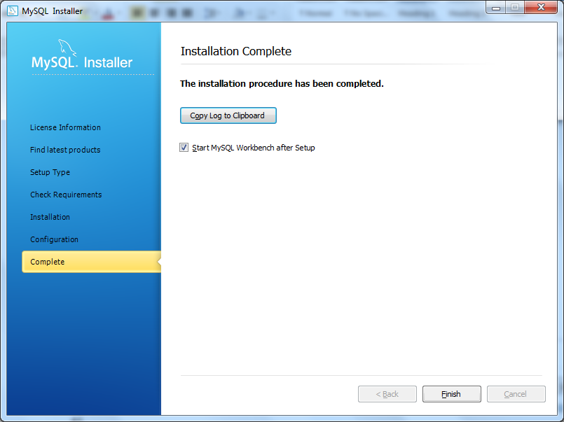
- Click on Finish.
- It should launch MySQL Workbench for you. The following screen will appear.
- 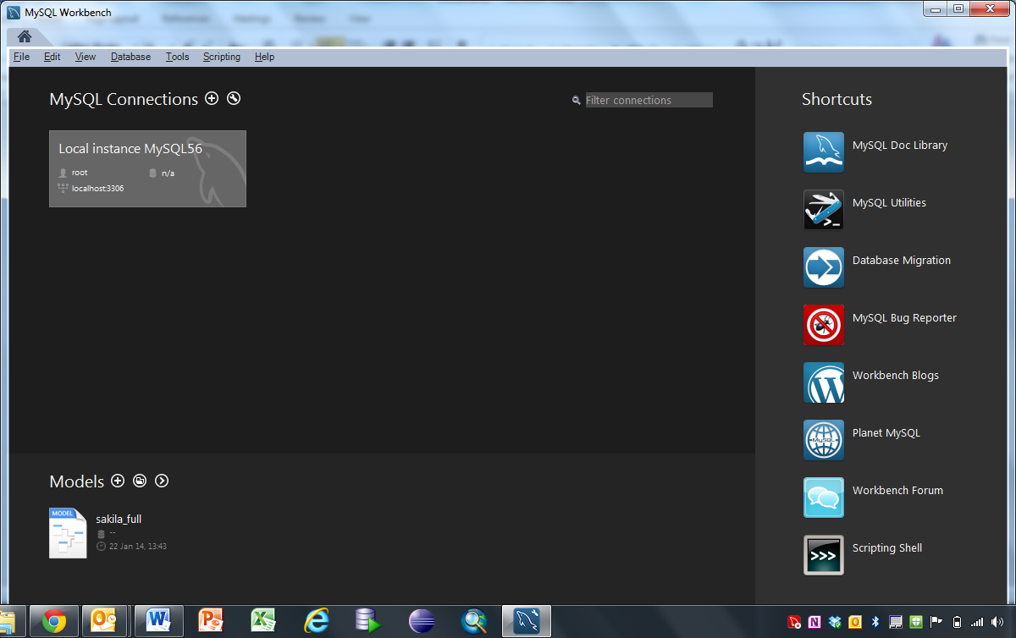
- Now you are done. Nothing else needs to be done at this point. Good Job!

