Getting Started with MySQL Workbench
- Administering a MySQL Server
In this section, you will use MySQL Workbench to carry out administrative functions, such as starting and stopping the server.
- Launch MySQL Workbench. You will be presented with the Home window.
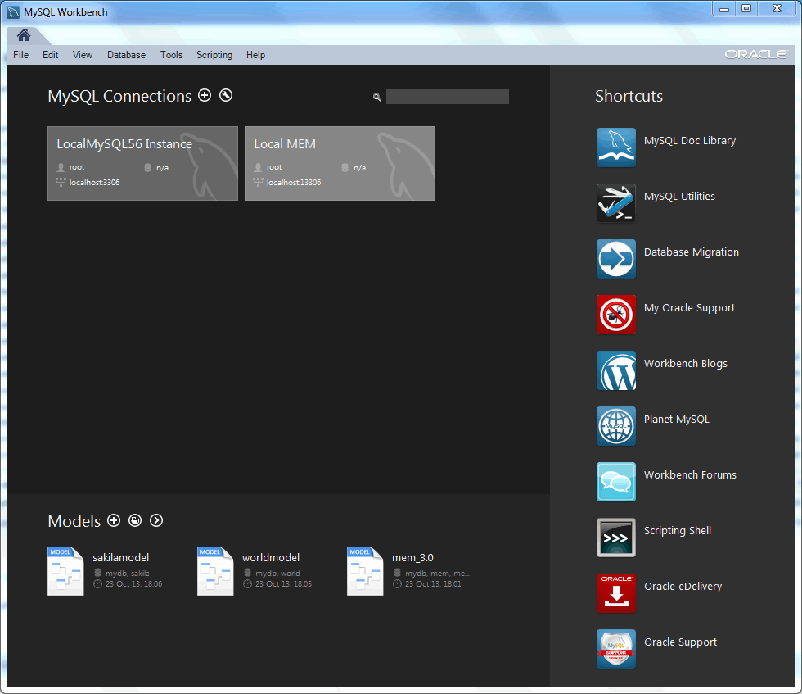
Figure 1. Getting Started Tutorial - Home Window
- To administer your MySQL Server, you must first create a MySQL Connection. Our example already has two connections created, but let us create a new connection. From the MySQL Workbench Home window, click the [+] icon near the MySQL Connections label. This opens the Setup New Connection wizard.
- Define the Connection Name value, which we will set to "MyFirstConnection" in this example.
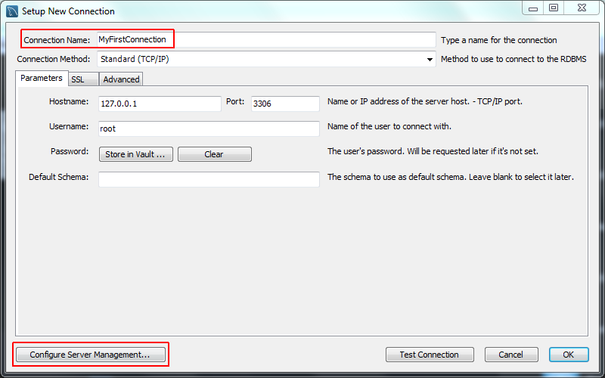
Figure 2. Getting Started Tutorial - Setup New Connection: MyFirstConnection
The default connection values are for a typical local setup, so check them and enter the appropriate values. If you are unsure, click the Test Connection button to check the connection parameters. Do not press OK.
Next, click Configure Server Management..., which opens up the Configure Local Management wizard:
- Read the Configure Local Management introduction, and press Next to begin defining the new connection parameters.
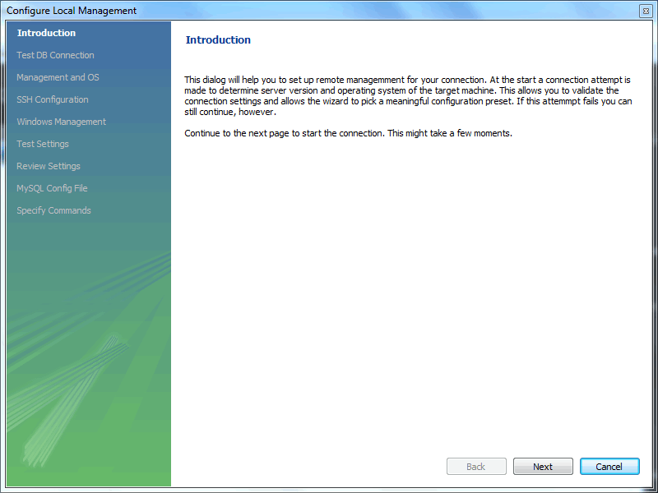
Figure 3. Getting Started Tutorial - Configure Local Management Introduction

- The connection will now be tested. You should see that the connection was successful. If not, click Back and check that you have entered the information correctly.
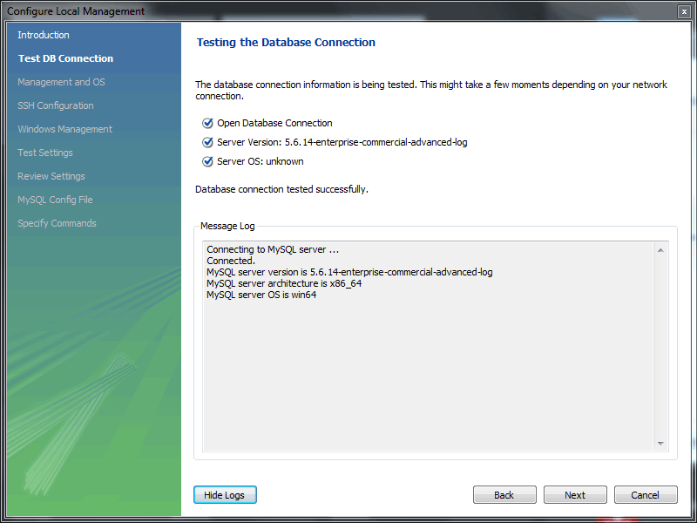
Figure 4. Getting Started Tutorial - Test Database Connection
Toggle the Show Logs to view additional details about the tested connection, then click Next.
- Optionally, you may configure a method for remote management if a Remote Host was specified. Setting these options enables MySQL Workbench to determine the location of configuration files, and the correct start and stop commands to use for the connection.
SSH login based management and Native Windows remote management types are available. The Operating System and MySQL Installation Type are configured for the SSH login variant.
We are creating a local MySQL connection in this tutorial, so are skipping the Management and OS and SSH Configuration options, as they are used for configuring a remote MySQL connection.
- On Microsoft Windows, select the appropriate MySQL service for the MySQL connection.
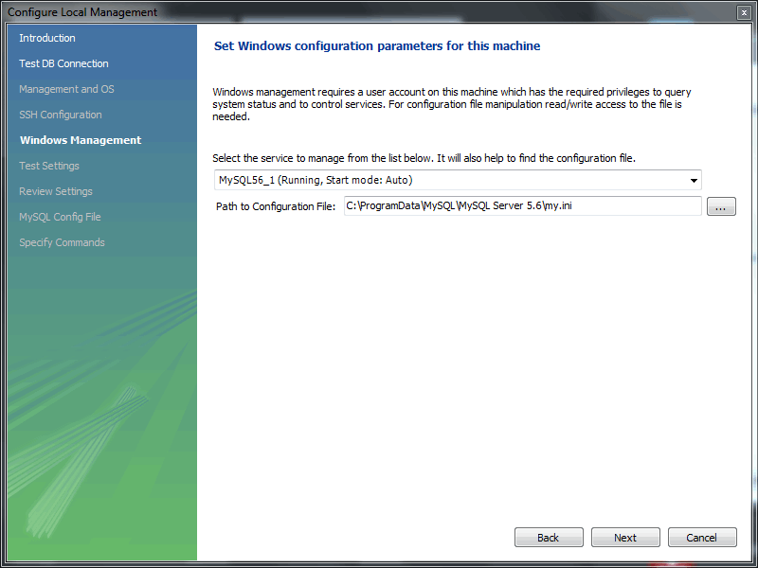
Figure 5. Getting Started Tutorial - Windows Management
- The wizard will now check its ability to access the start and stop commands, and check access to the MySQL Server configuration file.
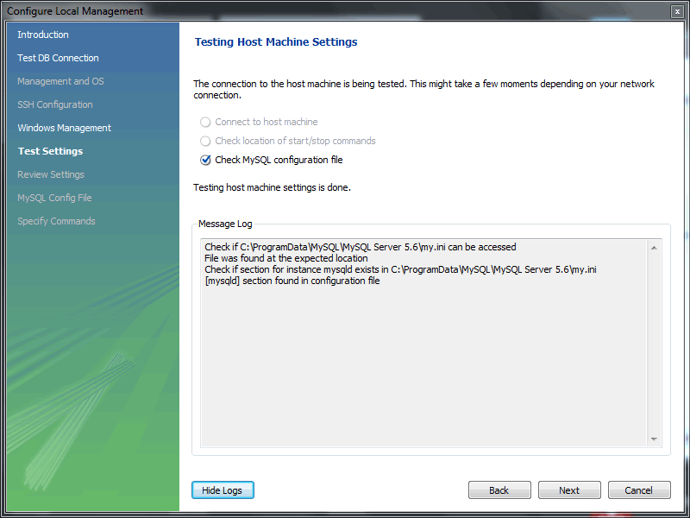
Figure 6. Getting Started Tutorial - Test Settings
- You now have a chance to review the configuration settings. The information displayed varies slightly depending on platform, connection method, and installation type.
At the Review Settings prompt, choose "I'd like to review the settings again" to review the settings. Choosing "Continue" closes the "Configure Server Management" dialog.
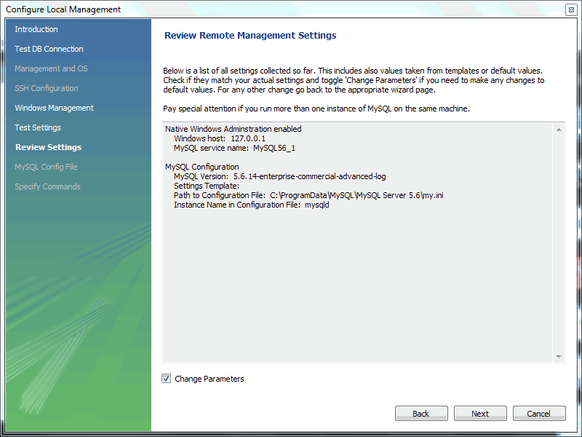
Figure 7. Getting Started Tutorial - Review Settings
Check the Change Parameters if you want to check or edit information about the MySQL configuration file. In our example we will check it, and click Next to continue.
- Review the MySQL configuration file information. Click the Check buttons to perform the described checks, or optionally change the configuration file path.
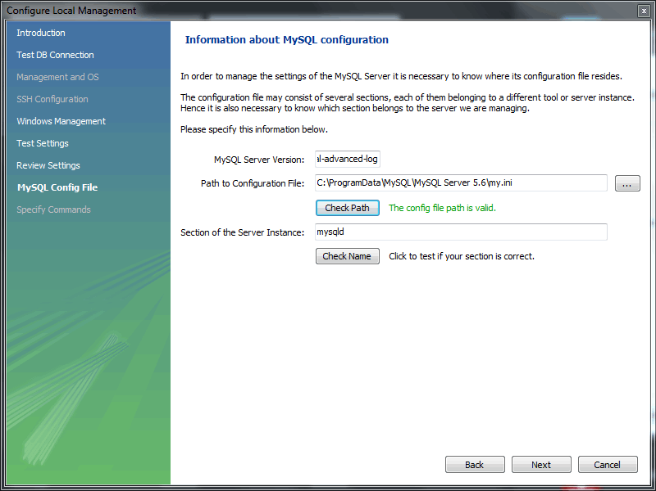
Figure 8. Getting Started Tutorial - MySQL Config File

- Optionally, enter your own commands for starting, stopping, and checking the MySQL connection. Typically the default values are used, which means leaving these optional values blank.
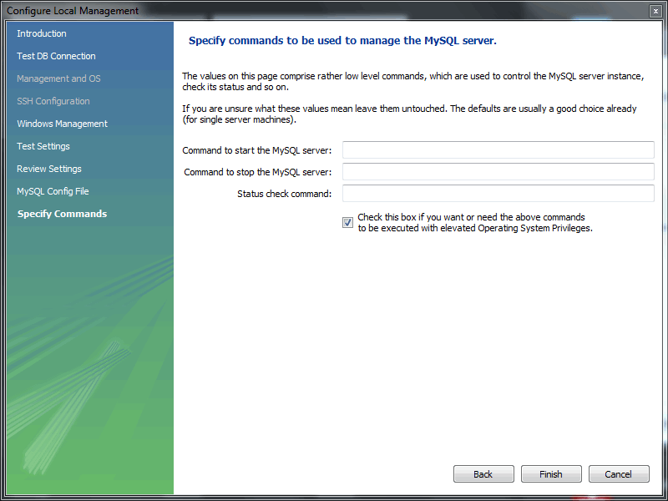
Figure 9. Getting Started Tutorial - Specify Commands
Click Finish to close the "Configure Server Management" dialog, which reveals the original Setup New Connection window.
- After reviewing the Setup New Connection information, press Test Connection again to make sure it still functions, and then OK to create the new MySQL connection.
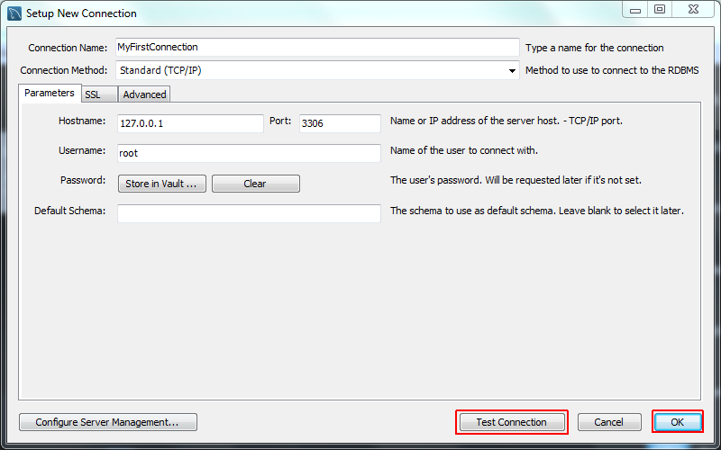
Figure 10. Getting Started Tutorial - Setup New Connection
- You will now be returned to the Home window. You will see the new MySQL connection that you created, named MyFirstConnection.
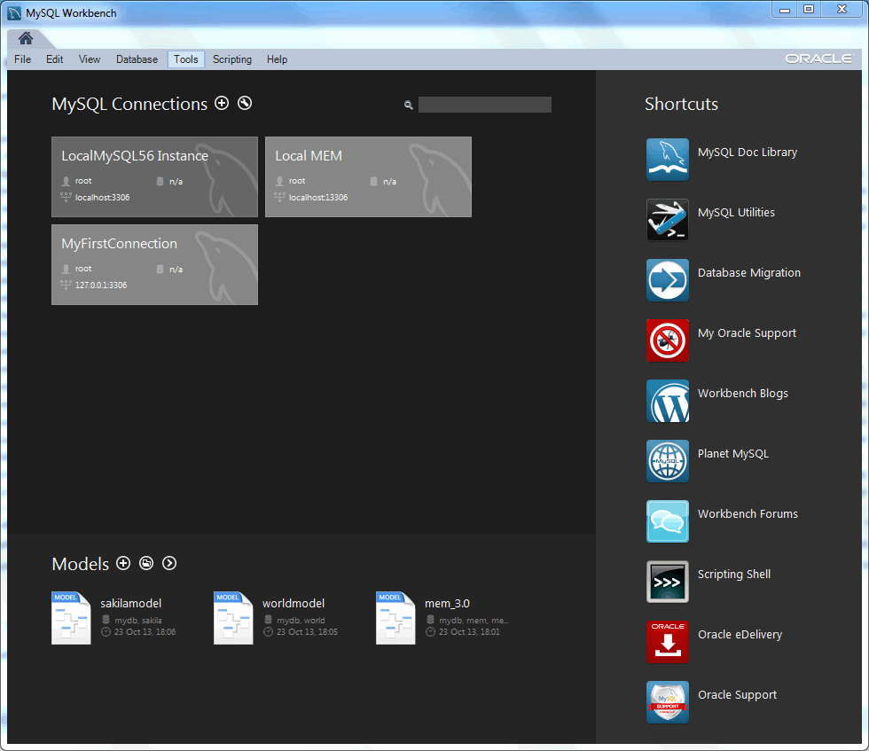
Figure 11. Getting Started Tutorial - Home Window Instance
You are now ready to test your new MySQL connection.
- From the Home window, double-click the MySQL connection you created to open up the SQL editor for this connection. The SQL editor is the default page, so now select the Server Status from the left Navigator panel. This displays the status of the MySQL server from your new MySQL connection.
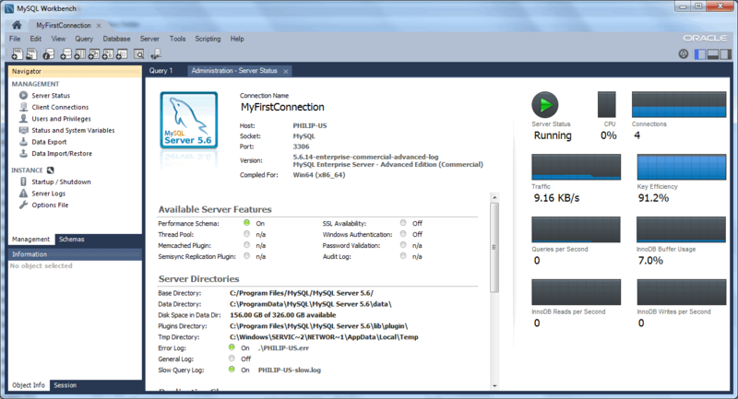
Figure 12. Getting Started Tutorial - Server Status
- Click around the Navigator panel and view the other MANAGEMENT and INSTANCE pages that relate to your new MySQL connection.
Notice the Management and Schemas tabs on the bottom of the Navigator panel. The Schemas view displays the schemas that are associated with your new MySQL connection. Alternatively, you can merge the Schemas and Management tabs by either clicking the merge icon on the top right of the Navigator panel, or by setting the Show Management Tools and Schema Tree in a single tab SQL Editor preference.
You have now seen how to create a MySQL connection to enable you to manage a MySQL server.

2. Creating a Model
In this section, you will learn how to create a new database model, create a table, create an EER Diagram of your model, and then forward engineer your model to the live database server.
- Start MySQL Workbench. On the Home window, click the [+] icon next to the Models section on the bottom of the page, or select File, New Model. A model can contain multiple schemata. Note that when you create a new model, it contains the mydb schema by default. You can change the name of this schema to serve your own purposes, or delete it.
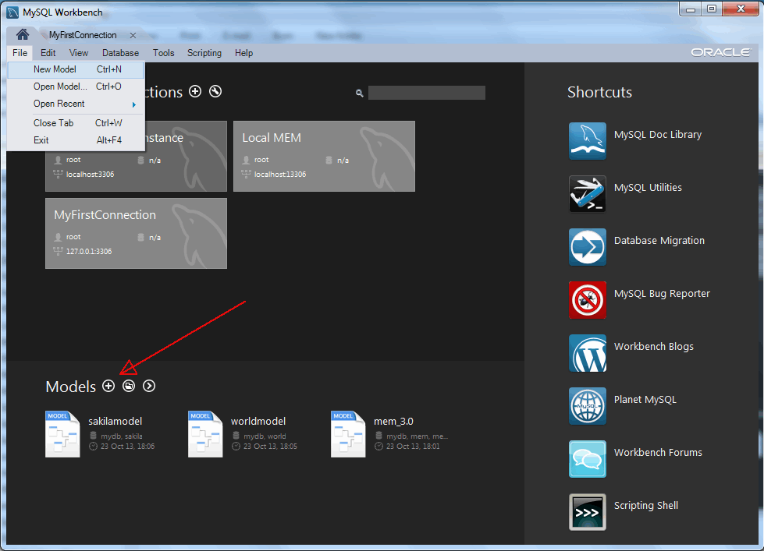
Figure 13. Getting Started Tutorial - Home Window
- On the Physical Schemata toolbar, click the button + to add a new schema. This will create a new schema and display a tabsheet for the schema. In the tabsheet, change the name of the schema to “dvd_collection”, by typing into the field called Name. Ensure that this change is reflected on the Physical Schemata tab. Now you are ready to add a table to your schema.
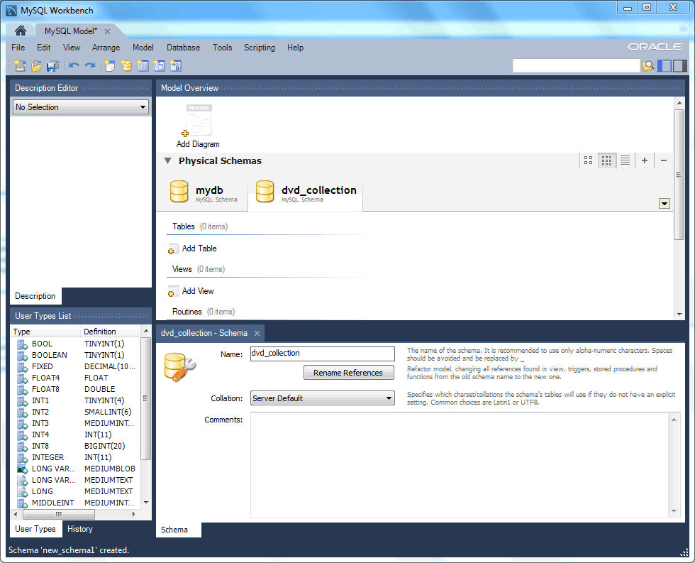
Figure 14. Getting Started Tutorial - New Schema
- In the Physical Schemata section, double-click Add Table.
- This will automatically load the table editor, with the default table name being table1. In the table editor, change the name of the table from “table1” to “movies”.
- Next, add several columns. Double click a cell within the Column Name column, and the first field will default to “moviesid” because MySQL Workbench appends “id” to the table name as the default for the initial field. Change the name to “movie_id” and keep the Datatype as INT. Then, be sure PK (PRIMARY KEY), NN (NOT NULL), and AI (AUTO_INCREMENT) are all checked.
- Add two additional columns using the same method as described above:
Column Name | Data Type | Column Properties
movie_title | VARCHAR(45) | NN
release_date | DATE (YYYY-MM-DD) | None
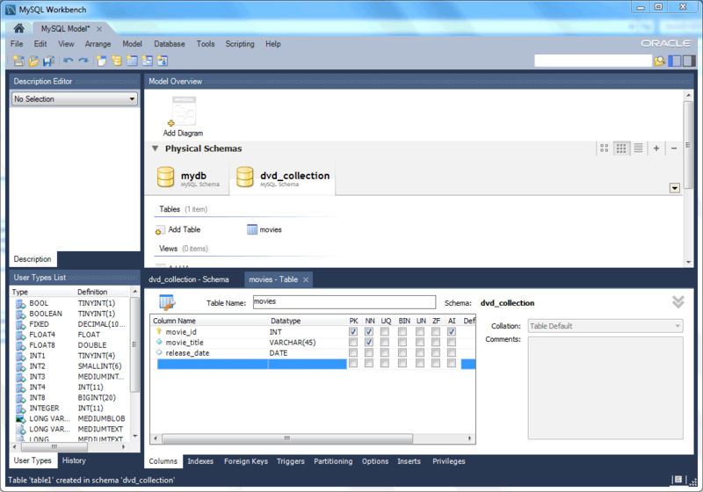
Figure 15. Getting Started Tutorial - Editing table columns
- Now you can obtain a visual representation of this schema so far. From the main menu, select Model, Create Diagram from Catalog Objects. The EER Diagram will be created and displayed.
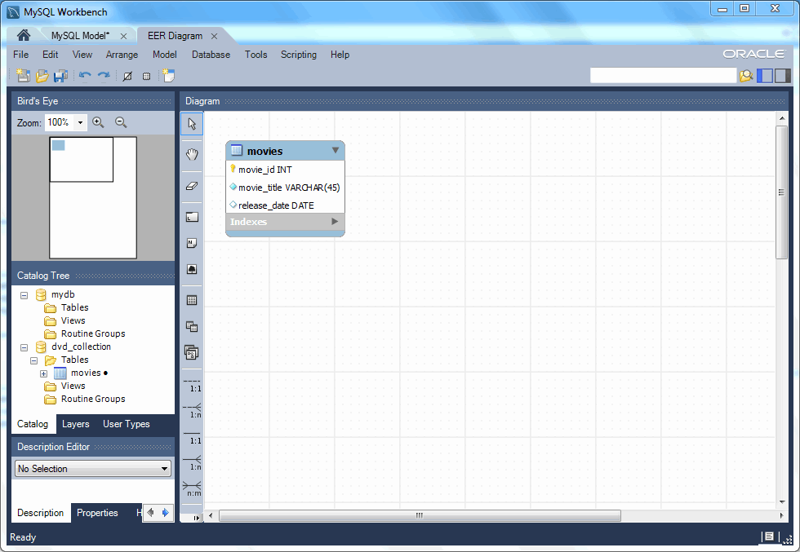
Figure 16. Getting Started Tutorial - EER Diagram
- In the table editor, change the name of the column “movie_title” to “title”. Note that the EER Diagram is automatically updated to reflect this change.
Note: There are several ways to open the table editor. Either change back to the MySQL Model tab and right-click on the movies table, or right-click on movies in the EER diagram and select an Edit 'movies' option.
- At this point, you can save your model. Click the main toolbar button Save Model to Current File. You have not yet saved this file so you will be prompted to enter a model file name. For this tutorial, enter “Home_Media”. The Home_Media model may contain further schemata in addition to dvd_collection, such as cd_collection. Click Save to save the model.
- You can synchronize your model with the live database server. First, tell MySQL Workbench how to connect to the live server. From the main menu, select Database, Manage Connections....
- Here you can create a new MySQL connection, or use a MySQL connection that you created previously. For our example, we will use the MyFirstConnection from the previous tutorial. To do this, select MyFirstConnection from the list of MySQL connections on the left.
- Click Test Connection to test your connection parameters. If everything is okay at this point, you can click Close.
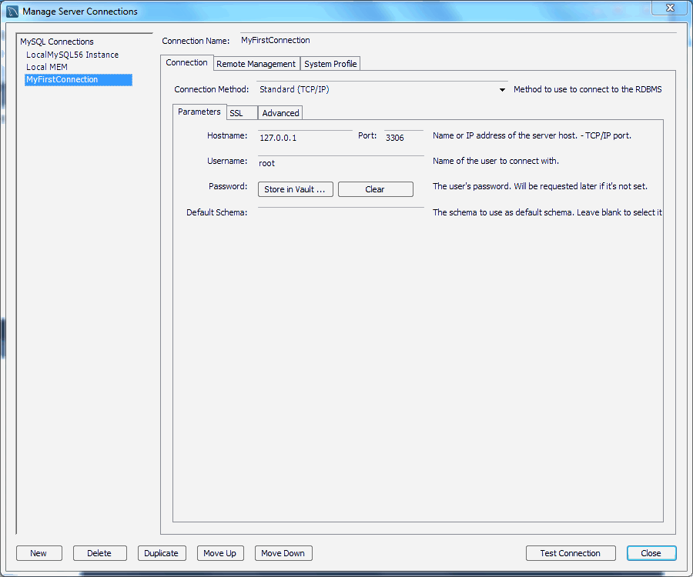
Figure 17. Getting Started Tutorial - Manage Connections
- You are now ready to forward engineer your model to the live server. From the main menu, select Database, Forward Engineer.... The Forward Engineer to Database wizard will be displayed.
- The Connection Options page of the wizard lets you set additional options for your selected MySQL connection. Or, you may decided to choose a different MySQL connection. We do not require any connection changes, so click Next.
- Optionally, you can execute a Catalog Validation. Click Run Validations and it should display "Validation Finished Successfully" without any errors.
- The Options page of the wizard shows various advanced options. For this tutorial, you can ignore these and simply click Next.
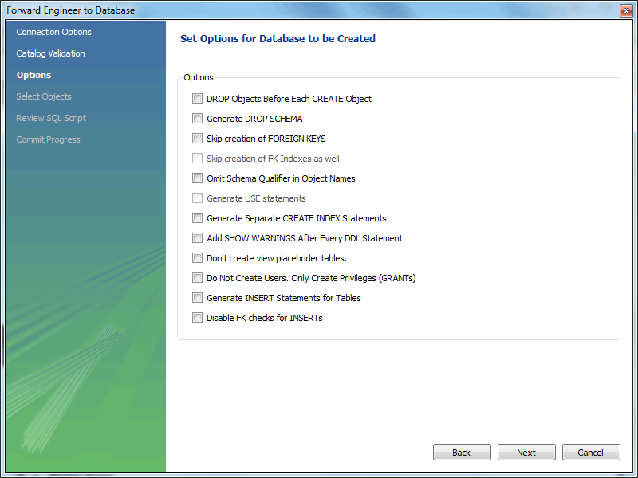
Figure 18. Getting Started Tutorial - Options
- On the next page, you can select the object you want to export to the live server. In this case, we only have one table, so no other objects need be selected. Click Next.
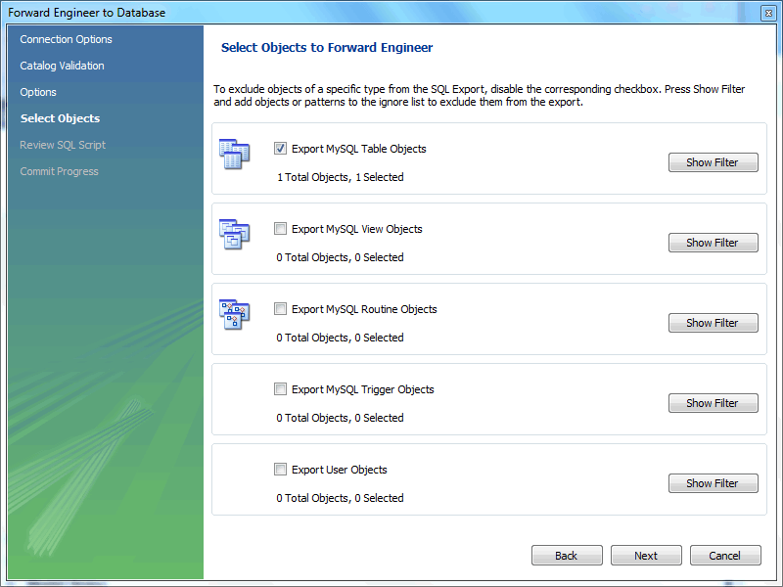
Figure 19. Getting Started Tutorial - Select Objects
- The Review SQL Script page displays the script that will be run on the live server to create your schema. Review the script to make sure that you understand the operations that will be carried out.
Clicking Next will execute the Forward Engineering process.
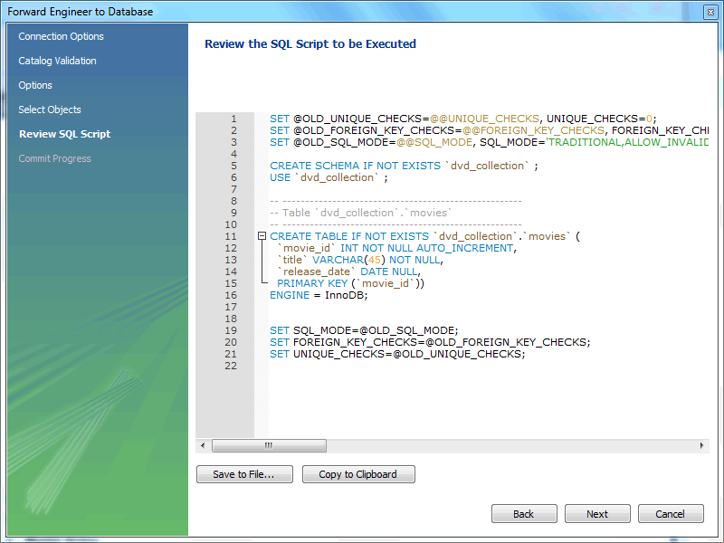
Figure 20. Getting Started Tutorial - Review SQL Script
- The Commit Progress page shows each executed step, and its associated status. It is recommended to view the logs on this page, so click Show Logs.
- After ensuring that the script ran without error on the server, then click Close. As a simple test that the script worked, launch the MySQL Command Line Client (mysql). Enter SHOW DATABASES; and identify your schema. Enter USE dvd_collection; to select your schema. Now enter SHOW TABLES;. Enter SELECT * FROM movies;, this will return the empty set as you have not yet entered any data into your database. Note that it is possible to use MySQL Workbench to carry out such checks, and you will see how to do this later, but the MySQL Command Line Client has been used here as you have probably used it previously.
- Ensure that your model is saved. Click Save Model to Current File on the main toolbar.

6.3. Adding Data to Your Database
In the previous section, you created a model, schema, and table. You also forward engineered your model to the live server. In this section, you will see how you can use MySQL Workbench to add data into your database on the live server.
Open the SQL Editor by opening a MySQL connection.
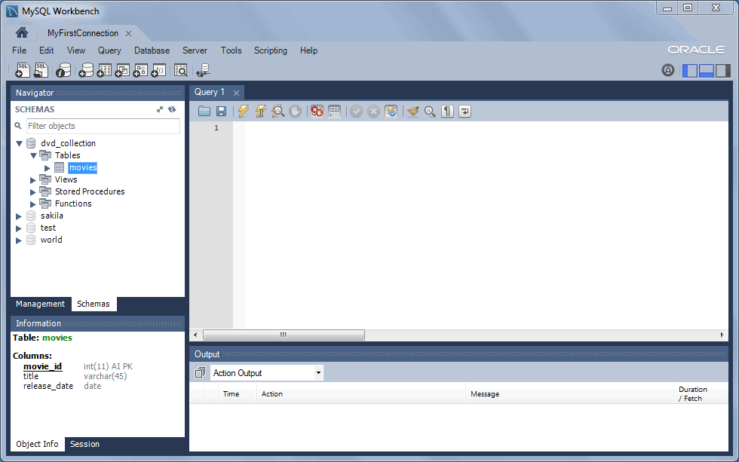
Figure 21. Getting Started Tutorial - SQL Editor
- From the Navigator panel on the left, select the movies table from the dvd_collection schema. Right-click on the movies table and choose Select Rows - Limit 1000.
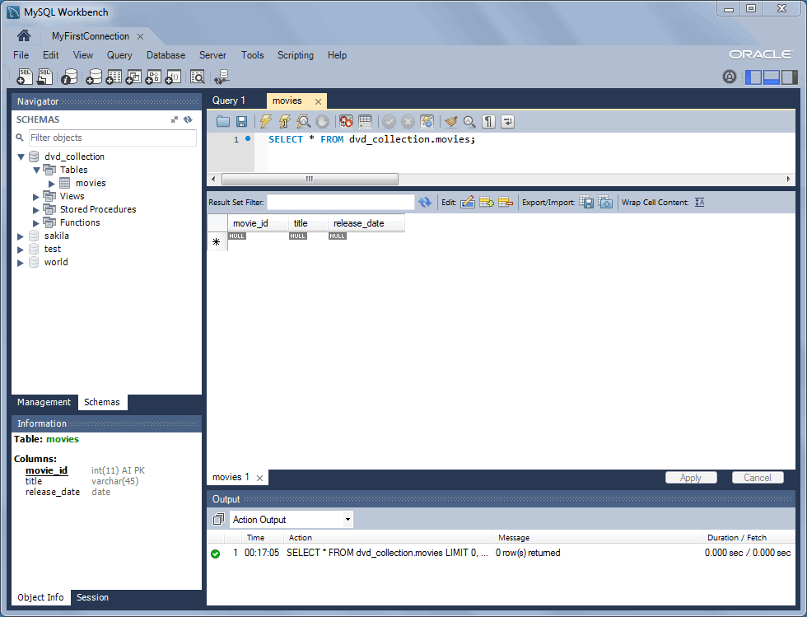
Figure 22. Getting Started Tutorial - Adding Data from the SQL Editor
- You will see the query and its associated data grid. This is where you can enter the data for your database. Remember that the movie_id was set to auto increment, so values are not needed for this column. In the data grid, enter the movie information shown in the following table.
title | release_date
Gone with the Wind | 1939-04-17
The Hound of the Baskervilles | 1939-03-31
The Matrix | 1999-06-11
Above the Law | 1988-04-08
Iron Man 2 | 2010-05-07
Note: Do not modify any values in the movie_id column.
- Now click the Apply button in the toolbar located in the bottom right corner. A list of SQL statements will be displayed. Confirm that you understand the operations to be carried out. Click Apply to apply these changes to the live server.
- Confirm that the script was executed correctly, then click Finish.
- View the data grid again and observe that the autoincrement values have been generated.
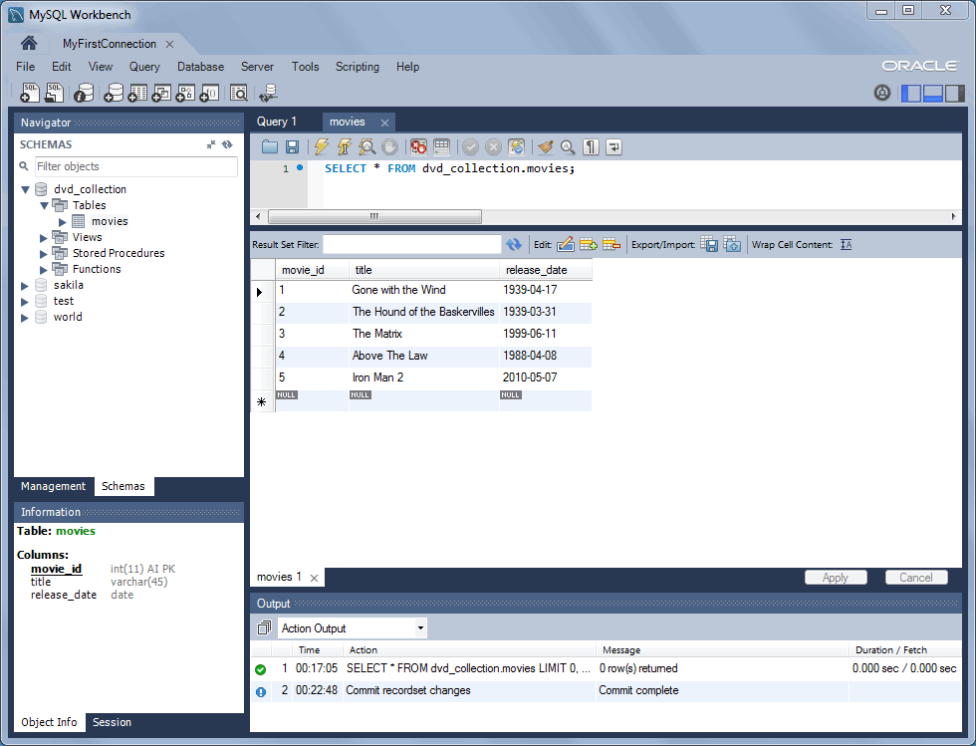
Figure 23. Getting Started Tutorial - Edit Data
- Now you will check that the data really has been applied to the live server. Launch the MySQL Command Line Client. Enter SELECT * FROM movies; to see the data just entered.
- You can also carry out a similar check from within MySQL Workbench. Close the MyFirstConnection tab, which should load the Home page. Now, click on the MyFirstConnection connection to load the SQL editor.
- A new SQL Editor tab will be displayed. In the Query area, enter the following code:
- USE dvd_collection;
- SELECT * FROM movies;
- Now click the Execute toolbar button. This resembles a small lightning bolt. The SQL Editor will display a new Result tab contain the result of executing the SQL statements.
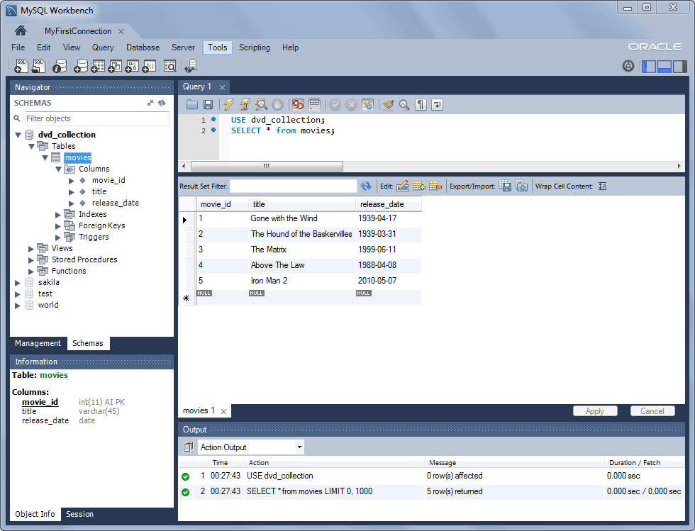
Figure 24. Getting Started Tutorial - Results

